LEMHEE-OKEE CHAPTER’S

**AWARD-WINNING**

NEWSLETTER

01

Edited by Brandon Eiler

**September**2013

The Limat

ISSUE

*“He who serves his fellows, is of all his fellows greatest!”*

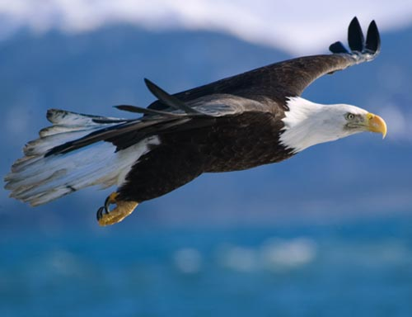

“An Unstoppable Adventure”

--  
Fall Fellowship  
2013

--

Section Seminars

Leadership

Brandon Eiler

chief@lemheeokee.org

Chapter Chief

Eric Cooper

advisor@lemheeokee.org

Chapter Advisor

Brandon Eiler

webmaster@lemheeokee.org

Publications/Web

http://lemheeokee.org

Chapter Update

September 5, 7pm -

Chapter meeting at Freedom Middle School

October 5

Cub Scout campout service and OA grill at Florida Elks Youth Camp

Lodge Update

September 6-8 -

Fall Fellowship at Camp La-No-Che

November 8-10 –

Section Seminars at Camp Soule

Membership Notes

Remember that by attending chapter meetings, you can add your voice to help plan future meetings and activities. At Tipisa.org you can update your membership status, pay dues, and find dates and locations as well as online and printer-friendly registration forms for upcoming lodge events.

*And So Said The Chief*

Brothers,

  Another Fall Fellowship is upon us and the theme is “An Unstoppable Adventure.” I encourage all arrowmen to join us for this weekend of fun, fellowship, and brotherhood. This weekend’s activities will consist of training seminars, quest for the golden arrow games, and other tournaments and games. There will also be great shows Friday and Saturday night. Also be sure to support our brotherhood candidates. Remember, registration closes September 2nd. I hope to see you there!

Brandon Eiler

Chapter Chief

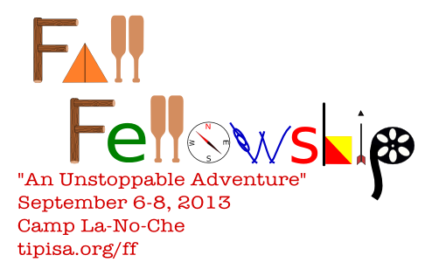

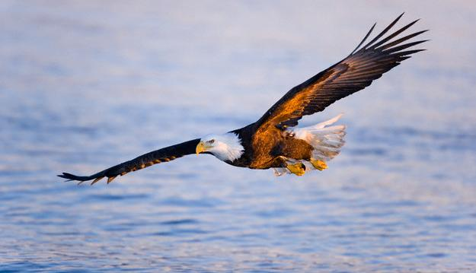

[](http://www.facebook.com/group.php?gid=104494229585235)

[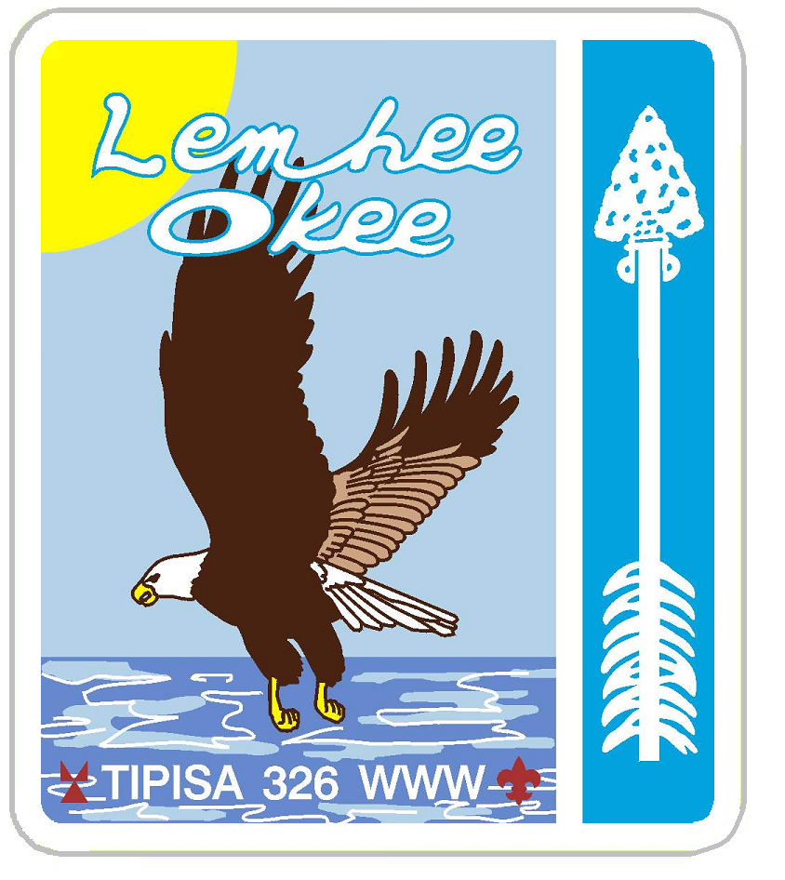](http://lemheeokee.org/)

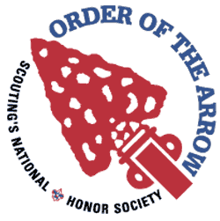

Want to contribute to our award-winning newsletter, The Limat? Just write about an OA, lodge or chapter-related topic and send it to webmaster@

lemheeokee.org

Join **Lemhee-Okee Chapter** on **Facebook**!

Receive updates, notices, and participate in discussions with your brothers online!

**Sand Lake District - Central Florida Council - Tipisa Lodge 326 - Section Four - BSA**

Like a quick breeze over the waves the eagle soars ever forward and higher …“and so shall we, this being our steadfast purpose,” said the mighty Chief.

**Your Scouting Experience Needed!**

Brothers,

For a chapter’s program to be successful, our committees need to have chairmen. It doesn’t take too much work to help out the chapter for the year. If you are interested in any of our open committees, please talk to the chapter chief or advisor.

Yours In Brotherhood,

Brandon EIler

**New Sashes Mean New Responsibilities**

By Frank Acevedo

Fall Fellowship is all about the lodge coming together for a vast array of exciting activities. However many attend to fulfill their membership by attaining the ‘bars and bonds’ of Brotherhood, and an annual few are chosen for the Vigil Honor. These levels are not ‘ranks’ above Ordeal, however they present an Arrowman with a higher understanding of the Order and also represent their dedication and future contributions. These new sashes mean new responsibilities. Members of all levels should see it as their personal responsibility to congratulate any fellow who has reached a new level during Conclave.