LEMHEE-OKEE CHAPTER’S
AWARD-WINNING
NEWSLETTER
04

March
2014
Edited by Brandon Eiler

The Limat
ISSUE

“He who serves his fellows, is of all his fellows greatest!”


Leadership

Brandon Eiler
chief@lemheeokee.org
Chapter Chief

Eric Cooper
cooptroops@yahoo.com
Chapter Advisor

Brandon Eiler
webmaster@lemheeokee.org
Publications/Web
http://lemheeokee.org

Andrew Colgan
racerdrew88@aol.com
Ceremonies Chairman
“A Hero’s Journey”
Fall Fellowship
2014
--
“The Arrowmen Effect”
Section Conference
2014

And So Said The Chief

Brothers,

Another Spring Conclave is upon us and the theme is “A Hero’s Journey.” I encourage all arrowmen to join us for this weekend of fun, fellowship, and brotherhood. This weekend’s activities will consist of training seminars, quest for the golden arrow games, and other tournaments and games. The highlight of the weekend may very well be the vigil call-out on Friday night. Our chapter’s theme is Robin Hood and his Merry Men, so dress accordingly! Remember, registration closes March 10th. I hope to see you there!

Brandon Eiler
Chapter Chief
Chapter Update
March 20, 7:00 PM -
Freedom Middle School

April, May, & June meetings and Chapter Banquet – TBD

Lodge Update
March 14-16 -
Spring Conclave at Camp La-No-Che

April 11-13 –
Section Conference at Camp Shands, Gainesville

May 16-18-
Service Weekend at Camp La-No-Che

Membership Notes
Remember that by attending chapter meetings, you can add your voice to help plan future meetings and activities. At Tipisa.org you can update your membership status, pay dues, and find dates and locations as well as online and printer-friendly registration forms for upcoming lodge events.


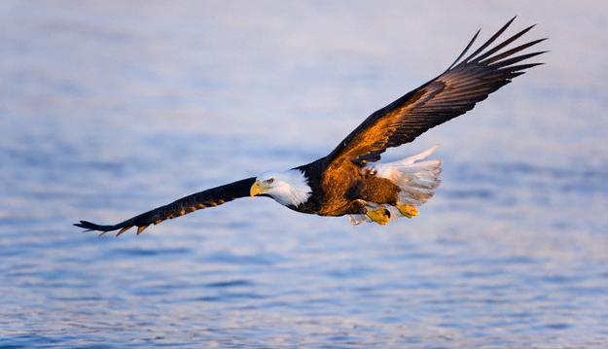

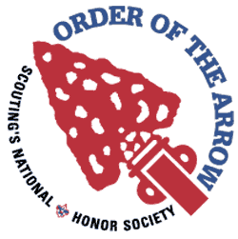
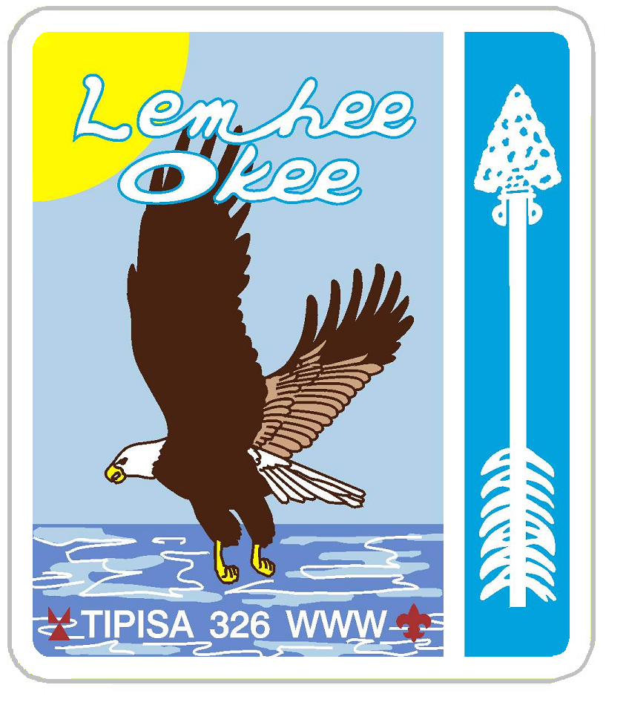


Want to contribute to our award-winning newsletter, The Limat? Just write about an OA, lodge or chapter-related topic and send it to webmaster@
lemheeokee.org

Join Lemhee-Okee Chapter on Facebook!
Receive updates, notices, and participate in discussions with your brothers online!

Like a quick breeze over the waves the eagle soars ever forward and higher …“and so shall we, this being our steadfast purpose,” said the mighty Chief.

Sand Lake District - Central Florida Council - Tipisa Lodge 326 - Section Four - BSA

New Sashes Mean New Responsibilities
By Frank Acevedo

Spring Conclave is all about the lodge coming together for a vast array of exciting activities. However many attend to fulfill their membership by attaining the ‘bars and bonds’ of Brotherhood, and an annual few are chosen for the Vigil Honor. These levels are not ‘ranks’ above Ordeal, however they present an Arrowman with a higher understanding of the Order and also represent their dedication and future contributions. These new sashes mean new responsibilities. Members of all levels should see it as their personal responsibility to congratulate any fellow who has reached a new level during Conclave.
Announcing Brotherhood Scholarships for Lemhee-Okee chapter Ordeal members!

Brothers,

There are those among you who have been faithful upon attendance of the sessions of the lodge, have lived the ideals of our order in their daily lives, and who are willing and entitled to learn more of our order.

Ordeal members of 10 months or more can sign up to seal their membership by obtaining brotherhood at Spring Conclave. We highly encourage you to do this!

The CEC has allotted chapter money for 10 brotherhood scholarships. Those of you who sign up for brotherhood will be randomly drawn to be reimbursed for your brotherhood sash cost.

Yours in Brotherhood,
Brandon Eiler
Chapter Chief

