LEMHEE-OKEE CHAPTER’S

**AWARD-WINNING**

NEWSLETTER

01

Edited by Brandon Eiler

**August**2012

The Limat

ISSUE

*“He who serves his fellows, is of all his fellows greatest!”*

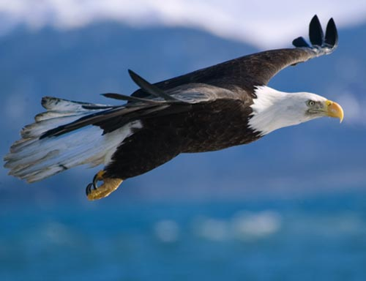

A New Year,

In Brotherhood,

Fellowship, and

Cheerful Service

Leadership

Brandon Eiler

chief@lemheeokee.org

Chapter Chief

Greg Batty

advisor@lemheeokee.org

Chapter Advisor

Brandon Eiler

webmaster@lemheeokee.org

Publications/Web

http://lemheeokee.org

Chapter Update

Our August 2nd chapter meeting will be the last at St. Nicholas Church. We are currently seeking a new meeting place.

September 6th is the following chapter meeting (location TBD). It will be Native American themed. If you want to learn how to dance or drum it is an excellent opportunity to learn.

Lodge Update

LLDP & Banquet is August 18 at the First United Methodist Church in Winter Park.

Fall Fellowship is September 7-9 at Camp La-No-Che.

Membership Notes

Remember that by attending chapter meetings, you can add your voice to help plan future meetings and activities. At Tipisa.org you can update your membership status, pay dues, and find dates and locations as well as online and printer-friendly registration forms for upcoming lodge events.

*And So Said The Chief*

Brothers,

   I can’t wait for the year ahead of us. Your chapter leadership has planned so many great things for us this year, many of which the chapter has never seen the likes of. Our goal is to be the Best All Around Chapter in Tipisa Lodge and be a Gold JTE Chapter. With lots of brotherhood, cheerfulness, and service, this is easily obtainable. I hope to induct many new brothers into our order this year and see our members, new and old alike, further their knowledge and obtain brotherhood. Maybe most important however, is that we all have lots of fun this year.

Brandon Eiler

Chapter Chief

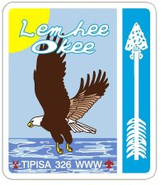

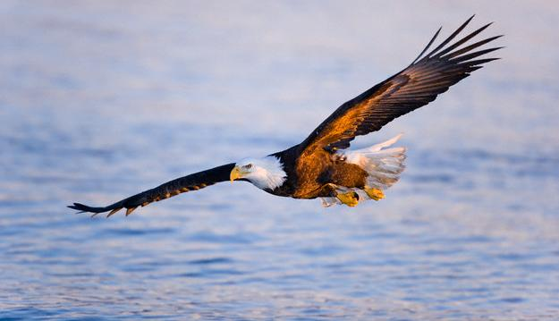

[](http://www.facebook.com/group.php?gid=104494229585235)

[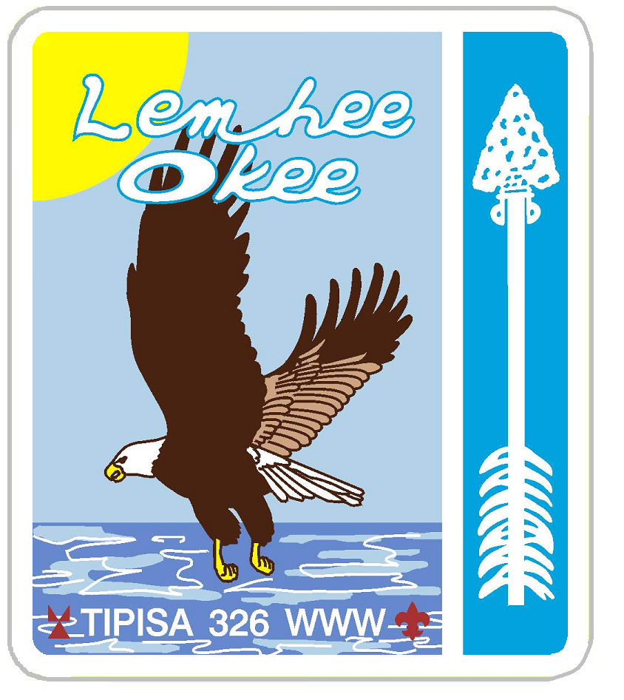](http://lemheeokee.org/)

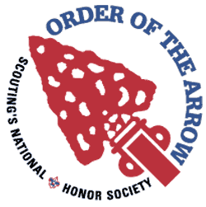

**Lemheeokee.org**

**Yahoo Group**

Want to contribute to our award-winning newsletter, The Limat? Just write about an OA, lodge or chapter-related topic and send it to webmaster@

lemheeokee.org

Join **Lemhee-Okee Chapter** on **Facebook**!

Receive updates, notices, and participate in discussions with your brothers online!

**Sand Lake District - Central Florida Council - Tipisa Lodge 326 - Section Four - BSA**

Like a quick breeze over the waves the eagle soars ever forward and higher …“and so shall we, this being our steadfast purpose,” said the mighty Chief.