LEMHEE-OKEE CHAPTER’S

**AWARD-WINNING**

NEWSLETTER

02

Edited by Brandon Eiler

**March**

2012

The Limat

ISSUE

*“He who serves his fellows, is of all his fellows greatest!”*

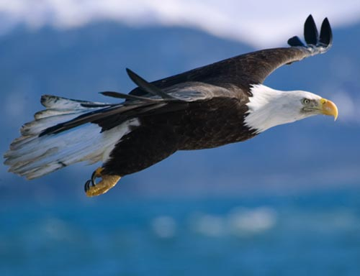

SPRING CONCLAVE   
&

SECTION CONFERENCE

2012

Leadership

Tyler Batty

chief@lemheeokee.org

Chapter Chief

Greg Batty

advisor@lemheeokee.org

Chapter Advisor

Brandon Eiler

webmaster@lemheeokee.org

Publications/Web

http://lemheeokee.org

Chapter Update

Chapter elections will be held at May’s chapter meeting.  All positions are open for election!  Please email [the chapter advisor](mailto:advisor@lemheeokee.org?subject=Intent%20To%20Run%20For%20Chapter%20Position) with your intent to run.

Our next meeting is Thursday, Oct. 2 at the usual location (St. Nicholas church on Sandlake Rd.) at 7:00 p.m.

Lodge Update

Spring Conclave will be held on March 16-18 at Camp La-No-Che.

Section Conference will be held on April 20-22 at Wallwood BSR.

Service Weekend will be held on May 18-20 at Camp La-No-Che.

Membership Notes

Remember that by attending chapter meetings, you can add your voice to help plan future meetings and activities. At Tipisa.org you can update your membership status, pay dues, and find dates and locations as well as online and printer-friendly registration forms for upcoming lodge events.

*Words of the Chief*

My brothers,

Greetings from your Lemhee-Okee Chapter Chief, Tyler Batty. I'm inviting you to the next lodge event, Spring Conclave. At Spring Conclave you can participate in seminars to learn more about the OA, Native American culture, how to run a chapter and much more. In the afternoon we will participate in chapter vs. chapter games. The weekend theme is Apocalypse Survival Training. Spring Conclave is March 16-18 at Camp La-No-Che. I hope to see you all there!

Tyler Batty

Chapter Chief

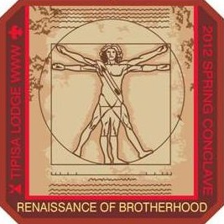

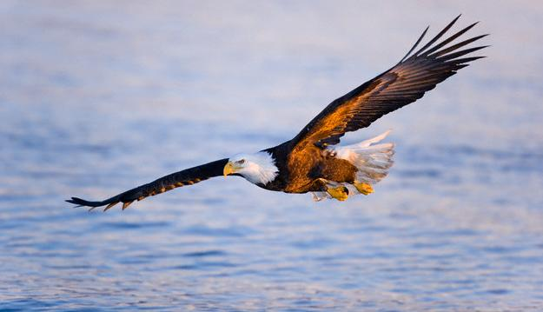

[](http://www.facebook.com/group.php?gid=104494229585235)

[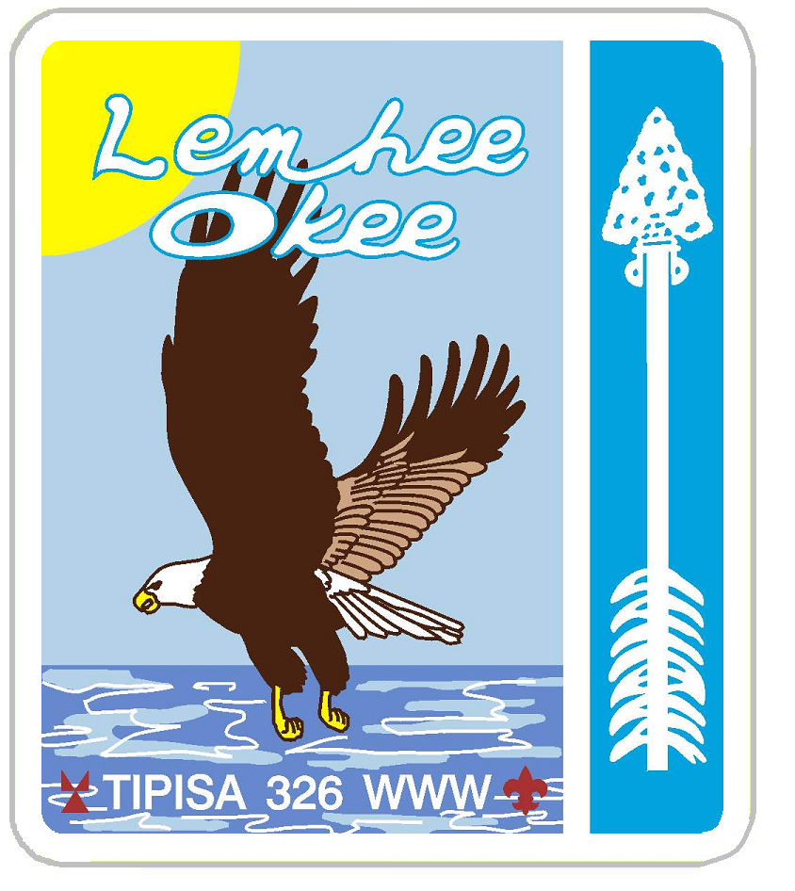](http://lemheeokee.org/)

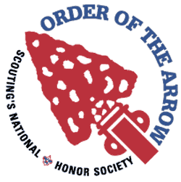

**Lemheeokee.org**

We now have a website that contains information for all arrowmen. You can find out information about upcoming events, and register for them. View pictures from chapter events, or find out how to contact your chapter leadership. We also have a forum for our members to engage in conversation and give out information. Our website is a valuable tool; use it to your advantage! You can visit our website at: <http://lemheeokee.org/>

**Yahoo Group** To increase chapter communication, you can now join the Lemhee-Okee yahoo group. To join visit, <http://groups.yahoo.com/group/lemheeokeechapter/>

..\My Pictures\yahoo_groups.gif

Want to contribute to our award-winning newsletter, The Limat? Just write about an OA, lodge or chapter-related topic and send it to webmaster@

lemheeokee.org

Join **Lemhee-Okee Chapter** on **Facebook**!

Receive updates, notices, and participate in discussions with your brothers online!

**Sand Lake District - Central Florida Council - Tipisa Lodge 326 - Section Four - BSA**

Like a quick breeze over the waves the eagle soars ever forward and higher …“and so shall we, this being our steadfast purpose,” said the mighty Chief.