LEMHEE-OKEE CHAPTER’S

**AWARD-WINNING**

NEWSLETTER

02

Edited by Brandon Eiler

**September**2012

The Limat

ISSUE

*“He who serves his fellows, is of all his fellows greatest!”*

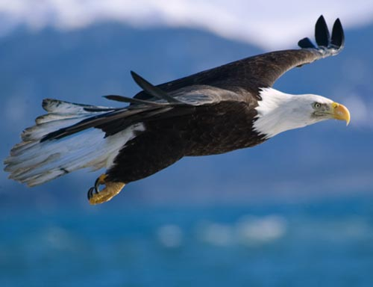

Arrgg!

--  
Fall Fellowship  
2012

Leadership

Brandon Eiler

chief@lemheeokee.org

Chapter Chief

Greg Batty

advisor@lemheeokee.org

Chapter Advisor

Brandon Eiler

webmaster@lemheeokee.org

Publications/Web

http://lemheeokee.org

Chapter Update

September 6th, 7:00 PM -

Chapter meeting at Bass Pro Shops.

October 4th, 7:00 PM -

Chapter meeting at Bass Pro Shops.

October 12-14 –

Supporting Sand Lake District’s Webelos Woods at Turkey Lake Park.

October 19-21 –

Supporting Sand Lake District’s Cub Family campout.

October 27th –

Project One Day

Lodge Update

Fall Fellowship is September 7-9 at Camp La-No-Che.

Section Seminars are November 16-18 at Camp Miles, Bradenton, FL.

Membership Notes

Remember that by attending chapter meetings, you can add your voice to help plan future meetings and activities. At Tipisa.org you can update your membership status, pay dues, and find dates and locations as well as online and printer-friendly registration forms for upcoming lodge events.

*And So Said The Chief*

Brothers,

   After having celebrating the past years achievements at our lodge banquet, which we had the most in attendance, I am looking forwards to another strong showing at Fall Fellowship. I encourage all arrowmen to join us for this weekend of fun, fellowship, and brotherhood. This weekend’s activities will consist of training seminars, quest for the golden arrow games, and other tournaments and games. For all interested in being an elangomat for our January ordeal, the lodge is offering an extended elangomat program; those who participate will be rewarded richly. Remember, registration closes September 3rd, I hope to see you there!

Brandon Eiler

Chapter Chief



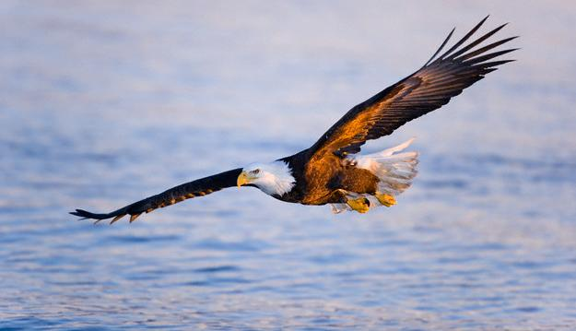

[](http://www.facebook.com/group.php?gid=104494229585235)

[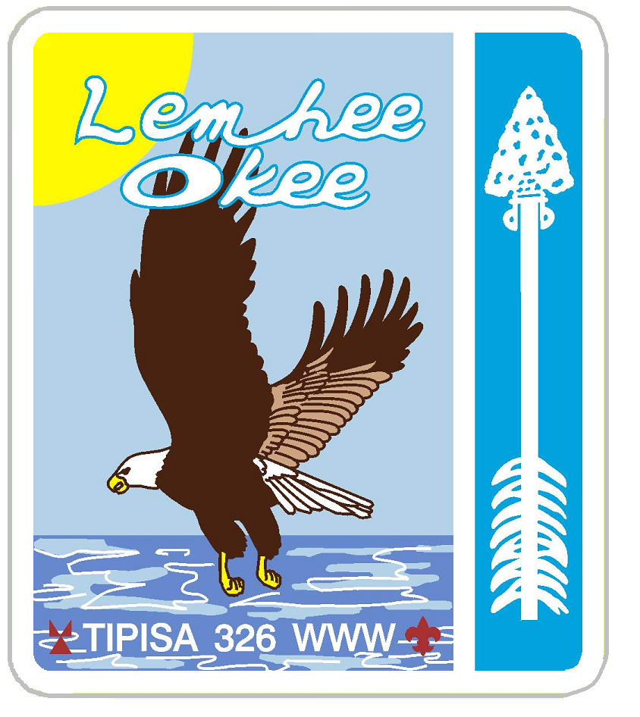](http://lemheeokee.org/)

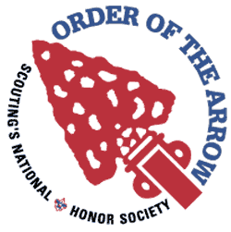

Want to contribute to our award-winning newsletter, The Limat? Just write about an OA, lodge or chapter-related topic and send it to webmaster@

lemheeokee.org

Join **Lemhee-Okee Chapter** on **Facebook**!

Receive updates, notices, and participate in discussions with your brothers online!

**Sand Lake District - Central Florida Council - Tipisa Lodge 326 - Section Four - BSA**

Like a quick breeze over the waves the eagle soars ever forward and higher …“and so shall we, this being our steadfast purpose,” said the mighty Chief.

**“What it means to be an Elangomat”**

By Frank Acevedo

Ordeal is a time of many things for chapters. It is a time for adding members, recovering members, and testing the chapter leadership’s ability to successfully run a weekend and induct members. Many important details of an Ordeal are covered during this stressful time by appointed arrowmen such as the Ordeal Master and Task Master, and the Chief diligently works under his Advisor to manage the communications, logistics and schedule for the weekend. However one role is left for the few youth willing to carry the traditional torch of brotherhood through the night, (in this case the oil torches!)

The role of the ***Elangomat*** is not one to be taken in uncertainty. During the weekend, those who don this responsibility must act accordingly with the most respectable and serious standards that our Order expects and instills. It is the Elangomat’s

responsibility to shine in the dark for those brothers-to-be as an inspiring image of membership in ‘Scouting’s National Honor Society.’ From my own perspective having served this role twice in the past as well as Head Elangomat, I truly recommend this position to any youth member who is willing to complete the cycle of service that made their own induction possible by being an ambassador for our chapter during its most vital time.